LAB- 4
Name: Prasad.S.Dhengale Roll no: 212010069
Aim: Debugging Node JS Application, Events, Express JS, Database connectivity and Template Engines
- Debugging Node JS - Steps for debugging:
Steps for debugging:
- Write the following code in the terminal window as shown below: node --inspect-brk-filename.js
The above command starts the debugger and stops at the first line.
Other commands for debugging :
  - next : Stop at the next statement.
  - cont : Continue execute and stop at the debugger statement if any.
  - Pause : Pause running code.
  - step : Step in function.
  - out : Step out of function.
Code:
var mysql = require('mysql');
var con = mysql.createConnection({ host:"localhost", user:"root",
password: "",
});

con.connect(function(err)
{
if(err)throw err; console.log("Connected!");
});

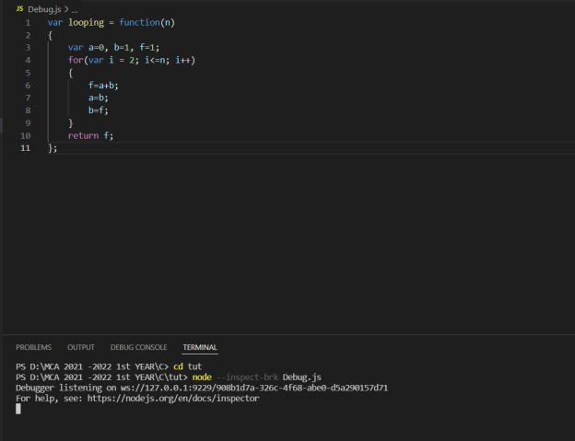

- Open your Chrome browser and write inspect as shown below: chrome://inspect/#devices
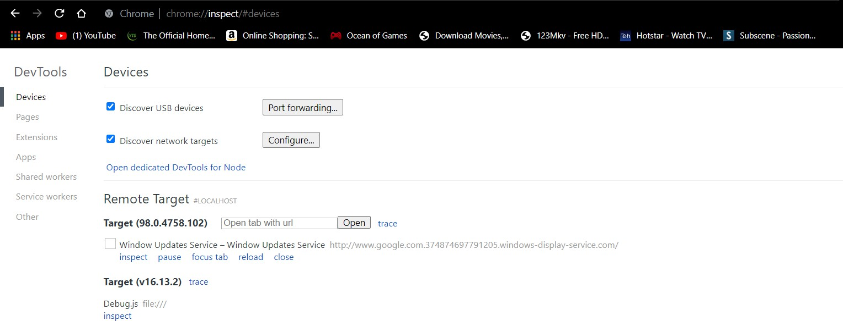

- Now click on Open Dedicated DevTools for Node.


- Now, click on the Node.js icon. The terminal will show the following message:
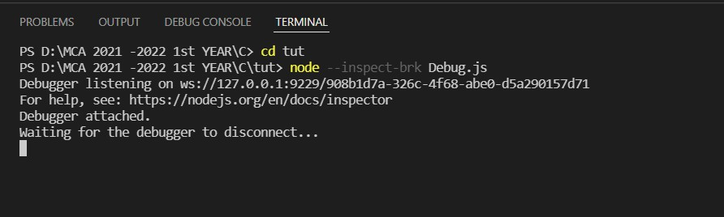
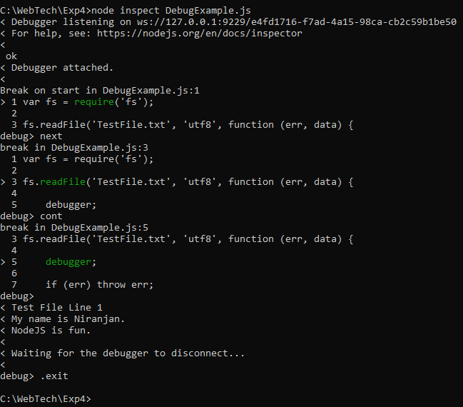

- Events
Node.js has a built-in module, called "Events", where you can create-, fire-, and listen for- your own events.
To include the built-in Events module use the require() method. In addition, all event properties and methods are an instance of an EventEmitter object. To be able to access these properties and methods, create an EventEmitter object:

Syntax:
var events = require('events');
var eventEmitter = new events.EventEmitter();

var myEventHandler = function()
{
console.log('Hello there');
}
eventEmitter.on('there',myEventHandler); eventEmitter.emit('there');

Output:


- Express
Express is a minimal and flexible Node.js web application framework that provides a robust set of features for web and mobile applications.
Syntax -
npm install express --save
Code:

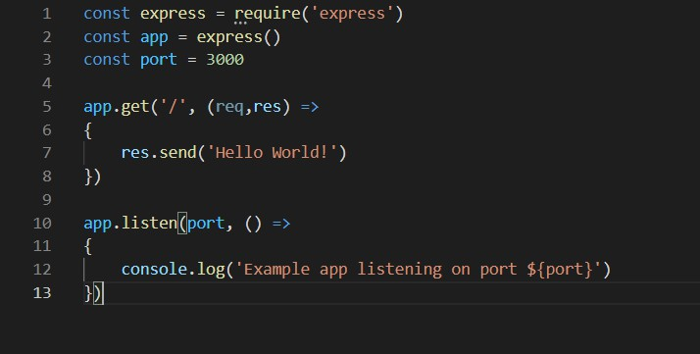

- Database connectivity and Template Engines
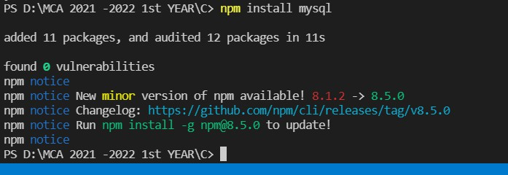
Code:
var mysql = require("mysql");

var con = mysql.createConnection({ host: "localhost",
user: "root",
password: "",

});

con.connect(function (err) { if (err) throw err; console.log("Connected!");
});

